**Linux Commands**

* **whatis** = Display one-line manual description
* **whereis** = Locate the path of the command
* **locate** = display absolute path of files and directories
* **man** = show the manual of commands
* **su -** = change to root
* **exit** = terminate normal processes
* **alias** = give a command to any letter
* **info** = shows information about a command
* **/ (inside a man, info document)** = to search
* **cp** = copy
* **gzip, gunzip, zip, unzip** = Zip and Unzip file
* **tar –cf** = Make an archive
* **tar –tf** = View files inside an archive
* **tar –rf** = Add new files to the archive
* **tar –xvf** = Extract the archive
* **head –n [10]** = display first 10 lines
* **tail –n [10]** = display last 10 lines
* **more** = read line by line
* **>** = Output, Redirects (Overrides)
* **>>** = Output, Redirects (Don’t override)
* **2>** = Redirects error to a text file
* **|** = To direct the output to another command (eg. ls –l | cat)
* **nl** = A numbered list of items

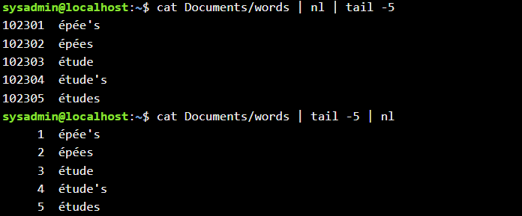

* **wc** = displays file statistics
* **sort** = sorts
* **cut** = cut parts in a file

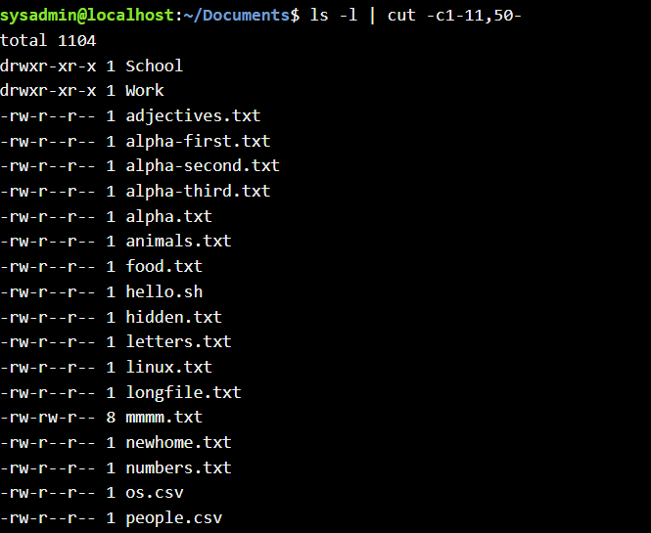

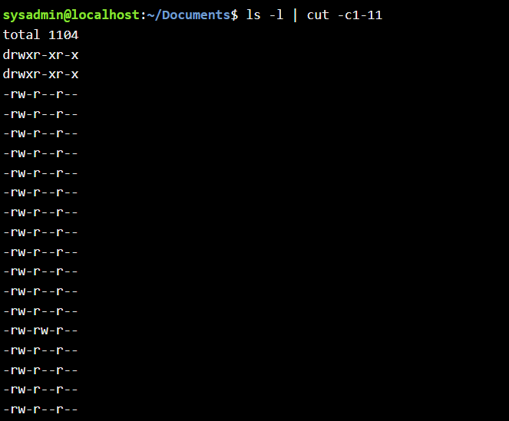

* **grep** = search files using regular expressions (by patterns)

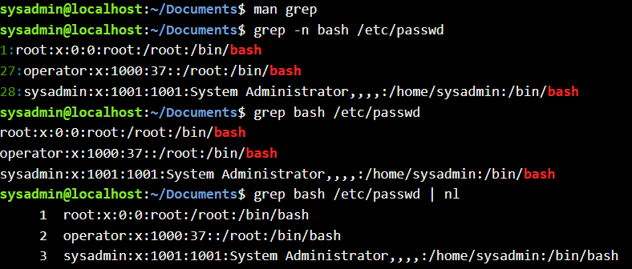

* **grep –n** = print number lines too
* **grep –c** = count of search

